

Structural Design

(Inside View)

**Vertical corrugation**

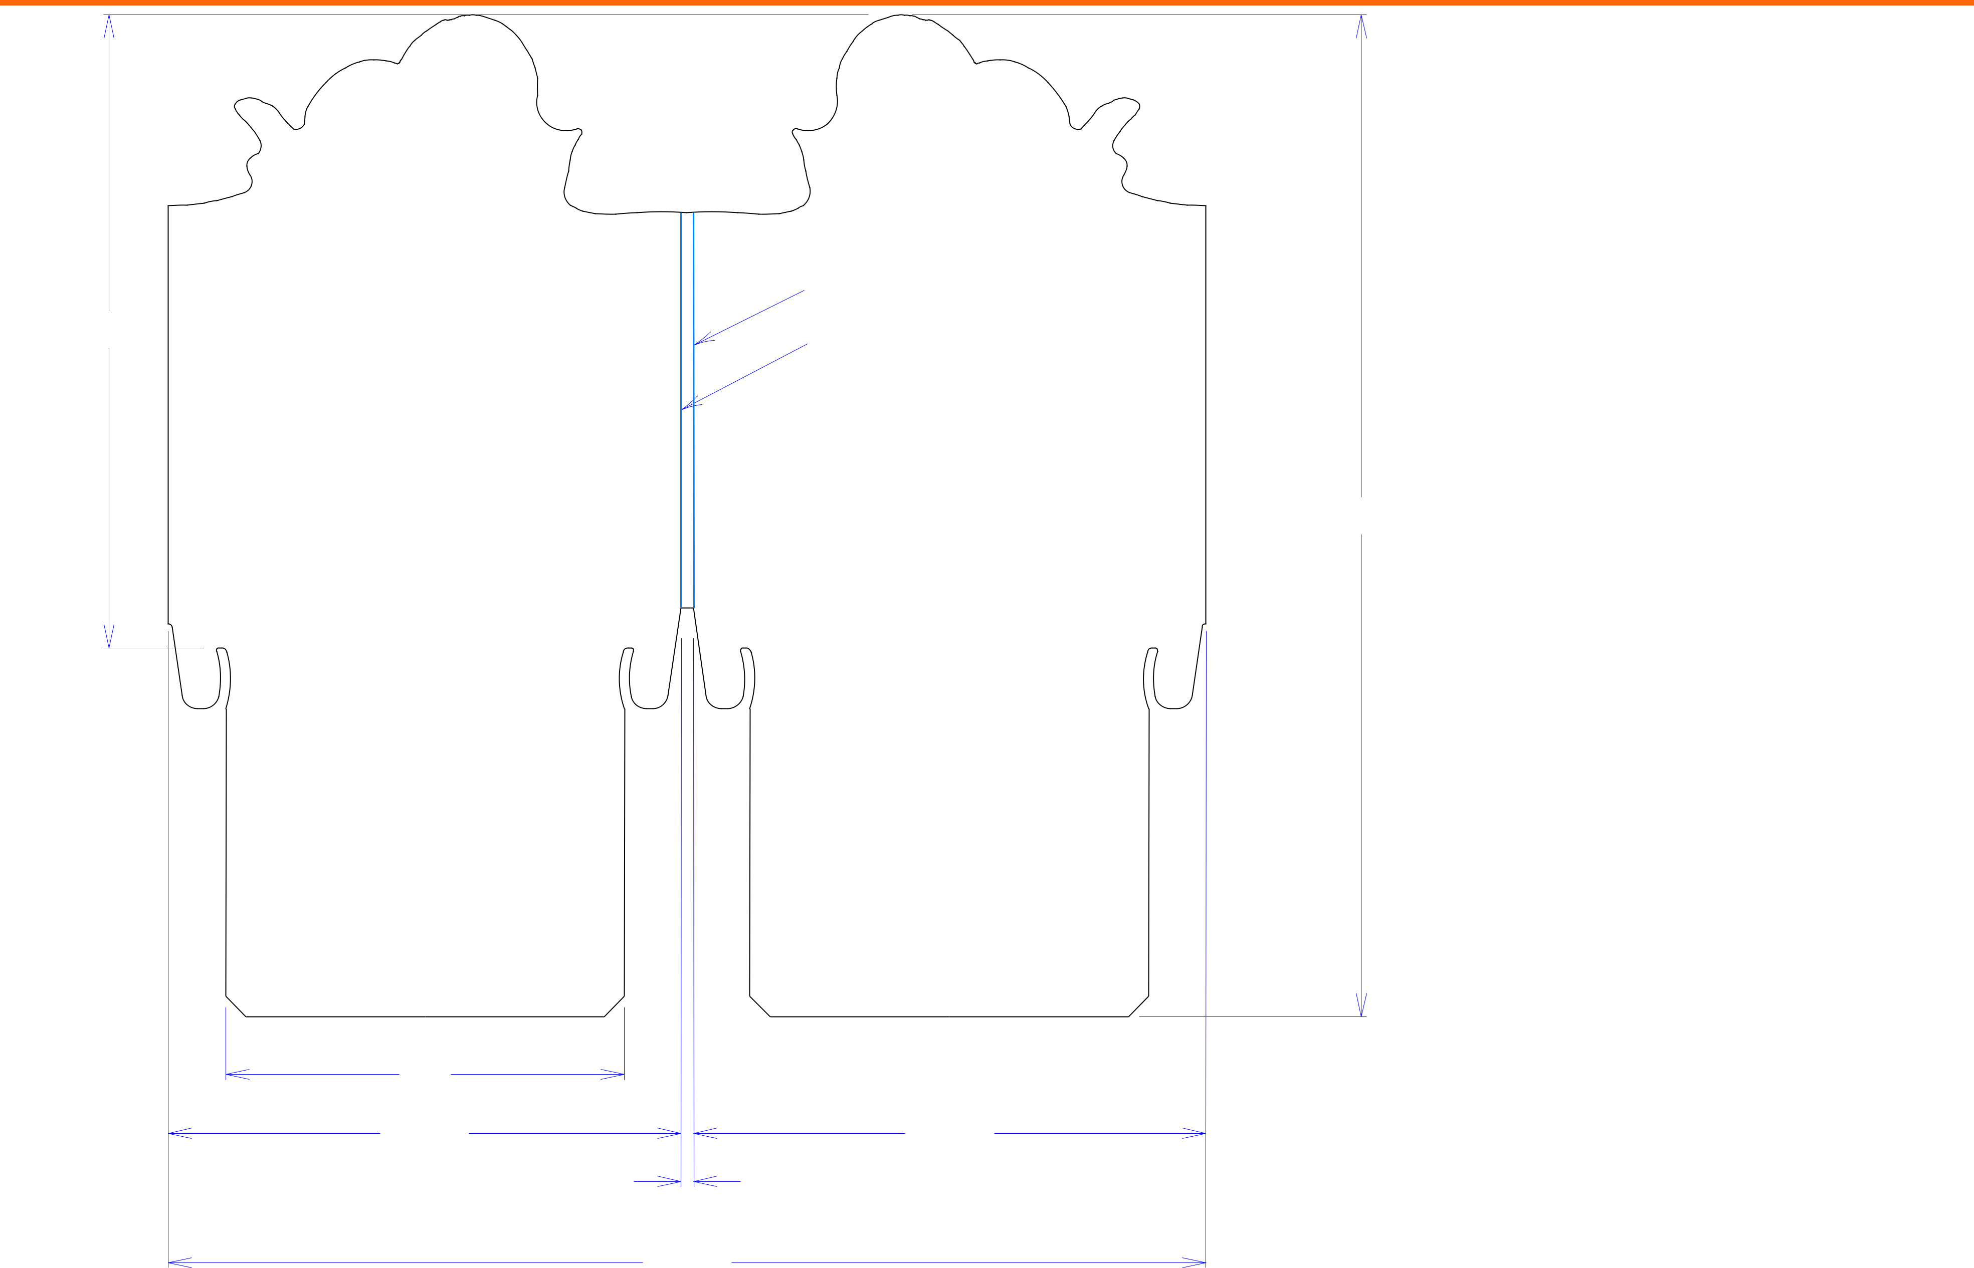

|  |  |  |
| --- | --- | --- |
|  | Design#: |  |
|  | **180562-01** |  |
|  | Customer: |  |
|  | **DeMet's Candy** |  |
|  | Description: |  |
|  | **Header - 5oz Flips qtr plt** |  |
|  | 1/4 1/4 cut & crease |  |
| 1511*/*16 | 1/4 1/4 cut & crease |  |
|  |  |

**SINGLE-OUT DRAWING**

|  |  |
| --- | --- |
| Qty/Unit: | **1** |
| Style: | **NJDC** |
| 2413*/*16 |  |

Board: **B flute**

Combination: **NA - NA - NA**

|  |  |  |  |  |  |  |  |  |  |
| --- | --- | --- | --- | --- | --- | --- | --- | --- | --- |
|  |  |  |  |  |  | I.D. : |  |  |  |
|  |  |  |  |  |  | Area of Blank - Waste : | | **3.61 sq. ft.** |  |
|  |  |  |  |  |  | Waste on Blank : | | **18.39%** |  |
|  |  |  |  |  |  | Finished Piece Weight: | | **0.01 lbs./3.77g** |  |
|  |  |  |  |  |  | Over-all Blank: **24+13/16 x 25+11/16** | | |  |
|  |  |  |  |  |  | Notes: |  |  |  |
|  |  | 97*/*8 |  |  |  |  |  |  |  |
|  |  | 1211*/*16 |  | 1211*/*16 |  |  |  |  |  |
|  |  | 5*/*16 |  |  |  | Revision Info: | **[0] 04/27/2018** | |  |
|  |  |  |  |  |  |  |  |  |
|  |  |  | 2511*/*16 |  |  | Designer: | **Alan Groff** | |  |
| Cut | Crease | Crease with Matrix | Cut Crease | Half Knife Cut | Tear Tape | Perforation |  |  |  |



Designright and Copyright of DS Smith Corrugated Packaging Ltd. This technical Specification is subject to Manufacturing tolerances. Drawing dimensions shown are crease to crease. Date printed: 08/27/2018